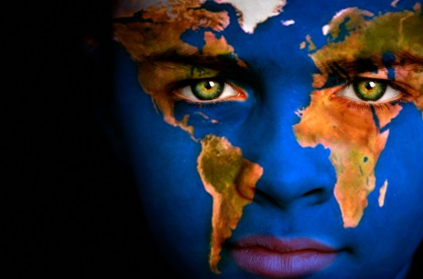
Global Perspectives Exploratory
Teacher: Mrs. Nixon
www.mrsnixonweb.weebly.com
jnixon@sd62.bc.ca
"We can't solve problems by using the same kind of thinking we used when we created them."
~ Albert Einstein

Global Perspectives is a new 10-week exploratory class geared for grade eight students at Spencer Middle School. In previous years this class was called ‘Global Action’, but it has been changed to reflect our transition to a 6-8 Middle School. Global Perspectives uses a project-based learning approach, where students will work collaboratively to learn about pressing global issues that affect all of us.
This class aims to empower students to be agents of change in their school, home and communities and will help students to:
- Increase their awareness of local and global social, cultural and environmental issues
- develop a positive self-outlook and leadership skills
- learn what other individuals and organisations are doing to make the world a better place
- Feel confident to take part in active, hands-on learning activities
Essential Questions:
- How do my actions impact people and the environment around the globe?
- What can I do to bring positive change to the world?
- What is a global perspective and why do I need to think about being a global citizen?
- What issues are affecting people and the environment at the local and global levels?
- What knowledge and skills are needed to make a difference in the world?
Course Outcomes:
By the end of this course, it is expected that you will
- develop an understanding of some of the issues that affect local and global communities, cultures and the environment
- learn how individuals and groups are helping to make the world a better place
- become an ‘agent of change’ and understand that together we can bring positive change to the world
- identify and enhance your unique character traits, and communication and leadership skills.

Potential Topics:
- Global citizenship and perspectives - What is a global perspective? Why is it important? What does it mean to be a global citizen?
- Values – individual, community and universal values, what are they? How are they transforming (i.e. technology)?
- Agents of change – how can we work together to bring forth positive change? What are other individuals and groups doing? What can I do?
- Local and global issues : poverty and homelessness; cross-cultural understanding and acceptance; environmental stewardship and climate change; human rights (children’s rights, indigenous rights); education; children in conflict; consumerism and consumer choices.

Supplies needed for every class:
- Binder and paper with an area or duotang for this course labeled ‘Global Perspectives’
- Pens, pencils and pencil crayons or felts
- Thin tip sharpie
- USB Flash drive (optional)
- Agenda
What is Global Education?
Global Education teaches students about…
• interconnections between social justice, economic, environmental, and political issues;
• the connection between the world and its people;
• the connection between themselves and their culture, themselves and others, themselves and the world;
• human potential and equality across the globe;
• how to look at the world from different perspectives;
• how to develop a more informed understanding of justice, human rights, and responsibilities; and
• how to encourage environmental sustainability through conscious choices.

